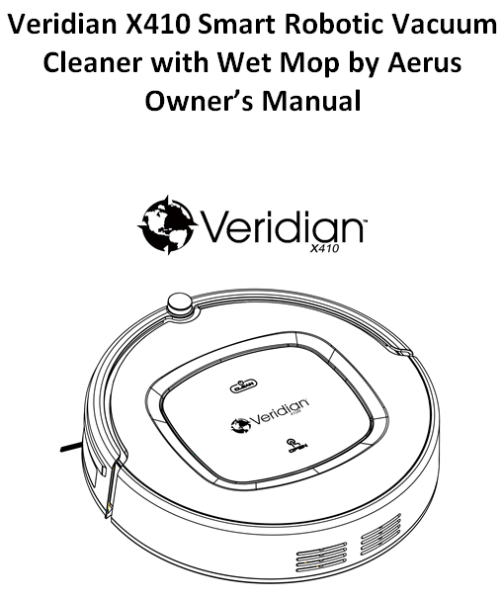

PLEASE READ AND SAVE ALL OF THESE INSTRUCTIONS

TABLE OF CONTENTS

Safety Instructions…….......................................................................3
Product Features……..................................................................... 4, 5
Product Components……................................................................6-9
Product Operation ……...............................................................10-13
Product Maintenance……..........................................................14, 15
Troubleshooting……........................................................................16
Battery Removal…….......................................................................17
Product Specification……...............................................................17

Thank you for purchasing your new Veridian X410 Smart Robotic Vacuum Cleaner with
Wet Mop by Aerus. We wish you many years of vacuuming with this high-quality appliance.
Please read this instruction manual to fully understand all of the operational features and
safety instructions for the robotic vacuum cleaner.

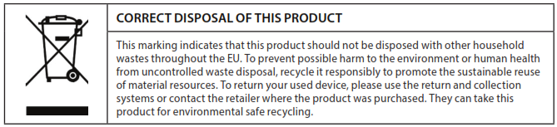

SAFETY INSTRUCTIONS

Your safety and the safe operation of this robotic vacuum cleaner are very important to us. All safety and operating instructions should be read, adhered to and followed before the unit is operated. Incorrect operation may cause harm or damage.

WARNING: only use the Veridian X410 Smart Robotic Vacuum Cleaner with Wet Mop by Aerus indoors. Improper use can be hazardous for your health and can lead to injury.

IMPORTANT SAFETY INSTRUCTIONS
- To prevent damage, remove all packaging from the vacuum prior to starting the unit.
- Repairs of the robotic vacuum should only be made by a qualified, professional and authorized repairman. Improper repair work can cause danger to the user.
- Only use the battery and power adapter that come with the vacuum. Using an unmatched battery or adapter may cause electric shock, fire or damage to the vacuum.
- Do not touch the power cord, plus or adapter with wet hands.
- Do not use this vacuum in a wet or moist environment (i.e. bathroom or laundry room).
- Prior to use, remove and clear away any objects on the floor to avoid accidents and property damage (i.e. cords, clothing, loose cables, etc.)
- Do not leave curtains or any type of fabric hanging on the floor where the vacuum could come into contact with them—the vacuum could get caught in them, causing damage.
- Do not use the vacuum near flammable substances or objects.
- Do not use the vacuum in an environment where there are combustible gases or vapors.
- Only use this vacuum indoors, never use it outside of your home.
- If the vacuum needs to be cleaned, clean it after it has been fully charged.
- Do not over-bend or press the power cord with heavy or sharp objects.
- Do not sit on top of the vacuum cleaner or attach any objects to the top of it.
- Always supervise children and pets when they are around the vacuum; never let them operate the unit.
- Always turn the vacuum off during transport or when you are not using it.
- Make sure the vacuum is fully assembled prior to operation.
- Before charging, make sure the power adapter is properly inserted into the wall outlet.
- Never insert foreign objects into the vacuum cleaner as this may cause electric shock or damage to the vacuum cleaner.
- Always check to see if the dust bin is full prior to use—when it is full, empty it before resuming operation.
- Do not use this vacuum in high-temperature environments or under direct sunlight for long periods of time.
- Dispose of the battery properly in accordance with your town’s regulations.
- Always unplug the power adapter from the wall outlet before cleaning the vacuum or removing the battery.

PRODUCT FEATURES

Powerful Suction & Intelligent Suction Adjustment
Powerful Suction:
This vacuum cleaner provides powerful suction. It is powerful enough to pick up the tiniest pieces of dust on the floor, ensuring your floors are cleaned thoroughly.

Intelligent Suction Adjustment:
The vacuum cleaner will automatically adjust its suction power when it detects different floor environments. Not only does this make cleaning more efficient, but it also helps to save power (up to 30%).

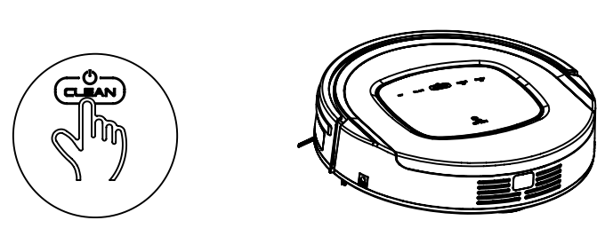
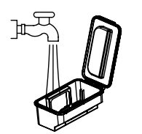
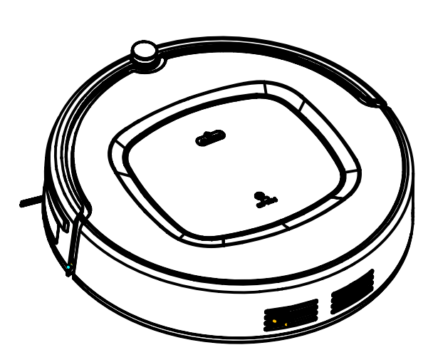
User-Friendly Design
Operation is simple and easy.

Simply touch the button
to start the robot.

Washable Dust Bin
You can wash the dust bin and filters with water. Simply
wash the dust bin under water after each vacuuming
session to avoid dust blowing back out into the air.

Multiple Cleaning Modes
The robotic vacuum offers multiple cleaning modes to meet your cleaning needs.

Auto Cleaning Mode:
The robot will automatically adjust its cleaning performance according to the environment.

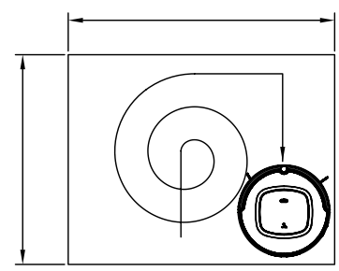

PRODUCT FEATURES CONT.

Spot Cleaning Mode:
The robot will spiral and focus on a specific spot when it detects a very-dirty area on the floor.

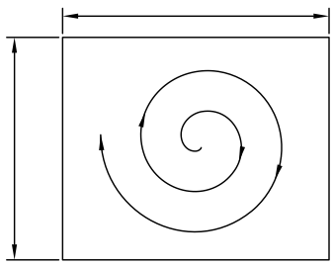

Edge Cleaning Mode:
The vacuum will clean along the edge of walls, obstacles or furniture in the room.
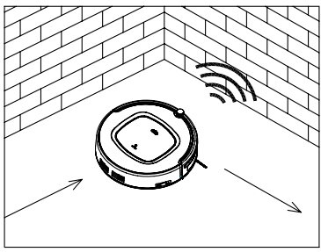

Scheduling Mode:
The vacuum will leave its charging station and will start vacuuming at the time you have scheduled it to operate at.
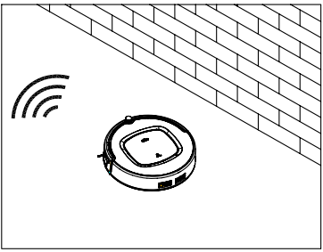

PRODUCT COMPONENTS

Main Body & Accessories

No. | Description | # Included
1 | Main Body | 1
2 | Charging Station | 1
3 | Remote Control (battery not included) | 1
4 | Power Adapter | 1
5 | Cleaning Brush | 1
6 | Side Brushes (2) & Spare Brushes (2) | 4
7 | Owner’s Manual | 1
8 | HEPA Filter | 1
9 | Water Tank | 1
10 | Mopping Cloth | 1

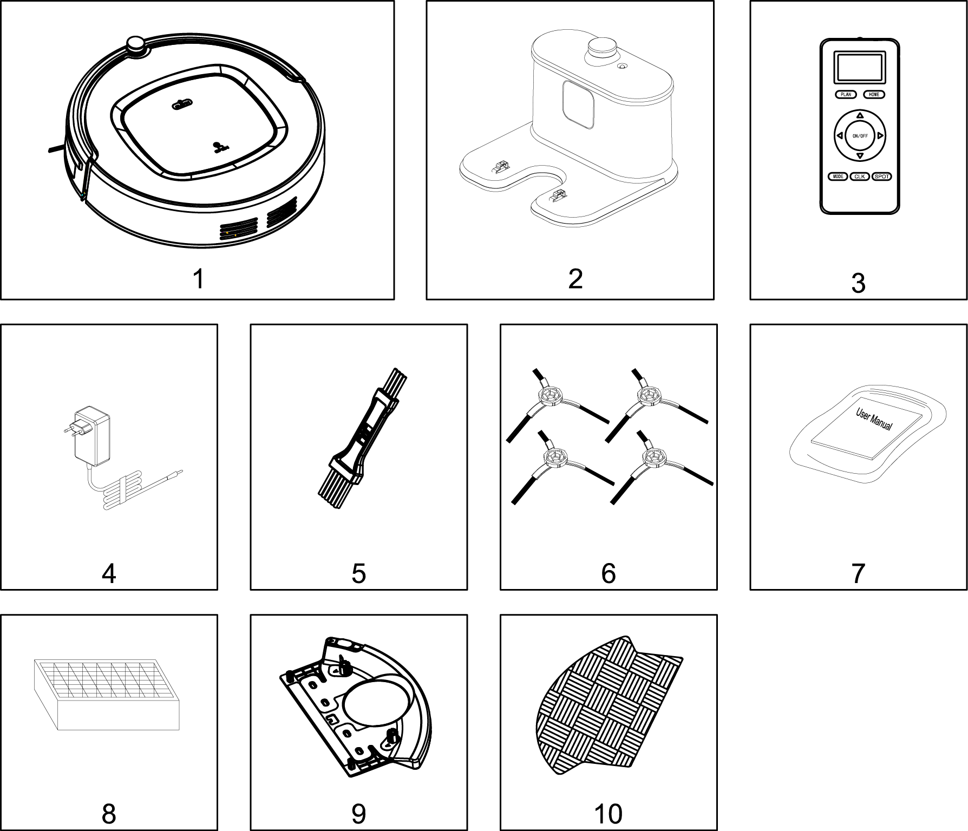

PRODUCT COMPONENTS CONT.

Main Body Diagram:
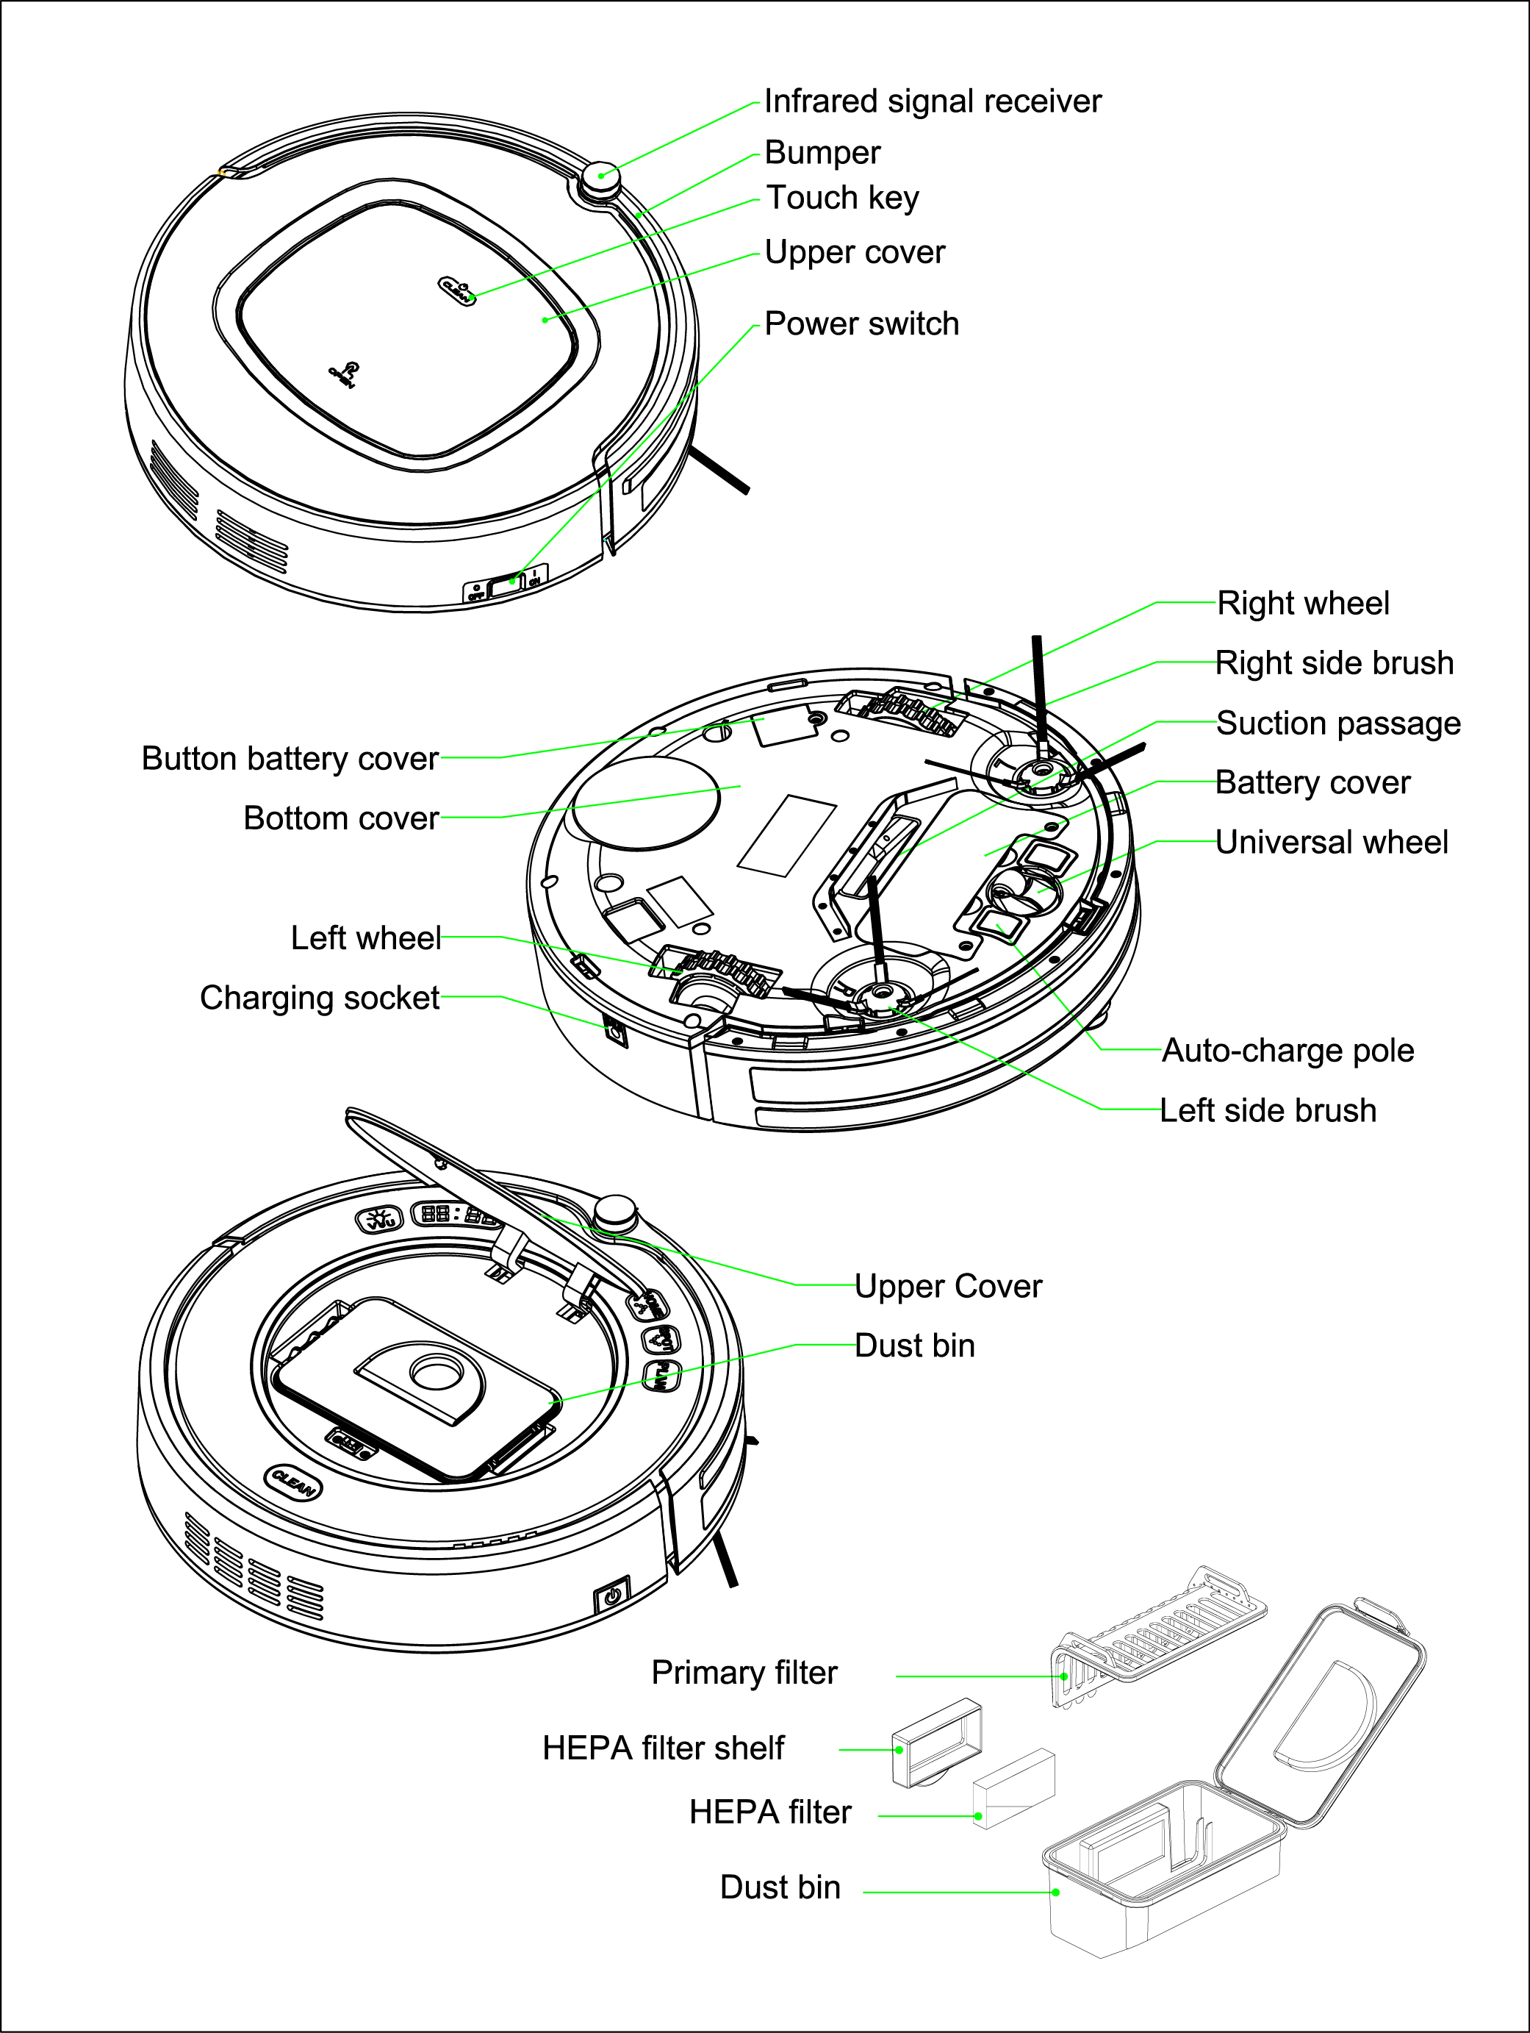

PRODUCT COMPONENTS CONT.

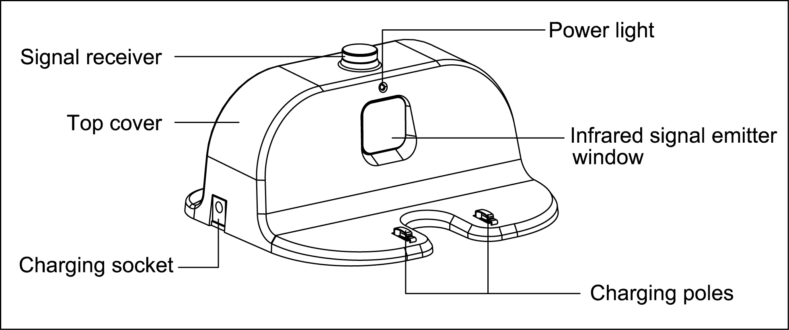
Charging Station:

Remote Control Buttons:
“HOME” Auto Charging:
Press the HOME button and the robot will return to the docking station to charge.

“ON/OFF”:
Press this button to change from sleeping mode to standby mode.
In working status, the robot will stop working when you press this button.
The robot will start cleaning when it is in standby mode.

“ ” Direction Buttons:
Press this button to increase the time in scheduling mode.
In other modes, press this button to change the direction of the machine.

“SPOT”:
While the vacuum is operating, press this button to initiate spot cleaning.

“MODE” - Cleaning mode selection button:
Press the MODE button and the robot will clean under the mode as shown on the LCD
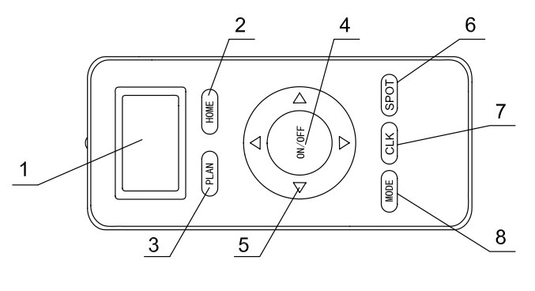
Mode 1: spiral cleaning
Mode 2: random cleaning
Mode 3: edge cleaning
Mode 4: S-shape cleaning

PRODUCT COMPONENTS CONT.

LED Display Panel
Battery Status Indicator “”:
When the robot is in standby mode or while it is vacuuming:
- RED – this means the battery power is low.
- BLUE – this means the battery is fully charged.

When the robot is charging:
- BLUE – this means the battery is fully charged.
- RED flash – this means the power switch needs to be turned on so it can charge.
- RED to BLUE gradual change – this means the vacuum is charging.

Robot Status Indicator “ ”:
Under standby status:
- If the indicator flashes gradually, it means the robot is charging properly.
- If the indicator flashes rapidly, it means robot is charging incorrectly. Please press CLEAN.

While the robot is cleaning:
- The indicator light will be on the whole time.

During charging:
- The indicator light will gradually change from red to blue when it is fully charged.

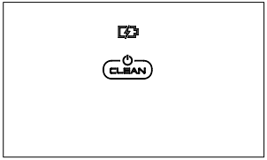

PRODUCT OPERATION

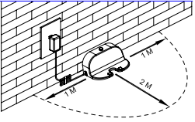
Charging station set-up:
Place the charging station up against the wall for use. Be sure to remove any obstacles that are around the charging station, leaving about 3 feet on each side and about 6 feet in front (see figure to the right).

Charging the robotic vacuum:
- While operating, the robot will automatically go back to the charging station when the battery is low and needs to be recharged.
- If you want to charge the vacuum, press the “HOME” button on the remote control to send the robot back to the charging station for recharging.
- Plug the power adapter into the robot and the wall outlet (see Fig. a below).

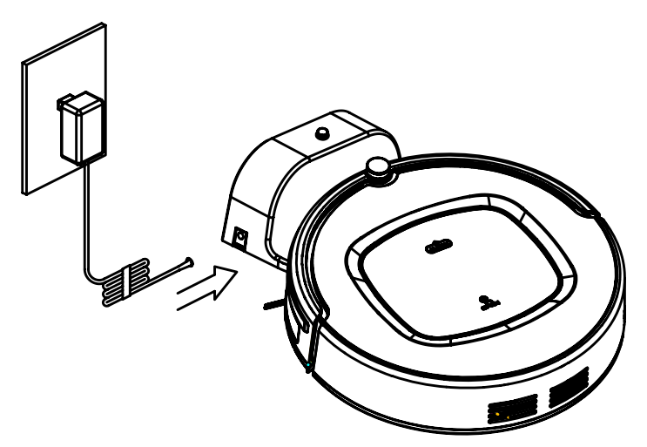

Fig. a

Steps to help extend the life of the battery:
- Charge the robot for 12 hours prior to using it for the first time.
- Charge the robot as soon as battery power is low—the robot will return to charging station automatically if the battery power is low.
- If you are not going to use the robot for an extended period of time, completely charge the battery, turn off the power switch and store it in a cool, dry location.

PRODUCT OPERATION CONT.

Start Up/Standby Mode/Sleep Mode/Powering Off

Start Up:

- Press the power switch on the right side of the robot.
- Press on the main body or “ON/OFF” on the remote control to start cleaning.
Note: If robot is in sleeping mode, press on the main body or “ON/OFF” on the remote control to wake the robot from sleep mode, then press again and the robot will start cleaning.

Standby Mode:
- When the robot is on, it will wait for the user to select the operating mode
- You can set the robot to standby mode by following this step:
  - While it is cleaning, press on the main body to initiate standby mode.

Sleep Mode:
- When in sleep mode, you can wake up the robot by pressing the button on the main body or the “ON/OFF” button on the remote control.
- To turn on sleep mode:
  - Press and hold the button on the main body for 3 seconds.
  - The robot will automatically enter sleep mode if it does not receive a command for more than 15 minutes.

Powering off:
- When in standby mode, press the power switch on the right side of the robot to turn the robot off.
- When in sleep mode, the robot will automatically shut off if it does not receive an operation command within 15 minutes and if there aren’t any upcoming cleaning schedules set.

PRODUCT OPERATION CONT.

Scheduling
You can schedule the robot to start cleaning automatically at a certain time each day.
- For example, at 9:00am, if you set the remote control to 6:30, then the robot will start cleaning after 6 hours and 30 minutes (it will begin at 3:30pm).
  - NOTE: Since it is daily scheduling, the robot will start cleaning at 3:30pm every day, unless the user turns off the power switch on the robot body.

How to set up scheduling mode via the remote control:
Scheduling can only be set when the robot is in standby mode or while it is charging.

- Press the “ON/OFF” button on the remote.
- Then press the “PLAN” button to enter the scheduling mode.
- Press the directional buttons to set the schedule:
  - Press "∧" and "∨" to set the numbers.
  - Press "﹤" and "﹥" to switch the numbers between hours and minutes.
- Press the “ON/OFF” button again to save the setting.

NOTE: to cancel the scheduled cleaning time, change the numbers on the display to show "00:00" or press and hold the “PLAN” button on the remote control for 3 seconds.

PRODUCT OPERATION CONT.

How to use the water tank and wet mopping cloth:
Step 1 (see fig 1):
- Attach the microfiber mopping cloth to the bottom of water tank.

Step 2 (see fig 2):
- Bring the water tank to the sink.
- Once at the sink, open the rubber plug and fill the water tank with cool tap water.
- Close the rubber plug on the water tank tight to avoid leakage.

Step 3 (see fig 3):
- Attaching the water tank to the robot.
- Turn the robot upside down and place the water tank onto the robot. Make sure to align the screw holes on the water tank and the robot body.
- Insert screws to attach the water tank to the robot body. Make sure the tank is attached tightly to the robot so it cannot move around or fall off.

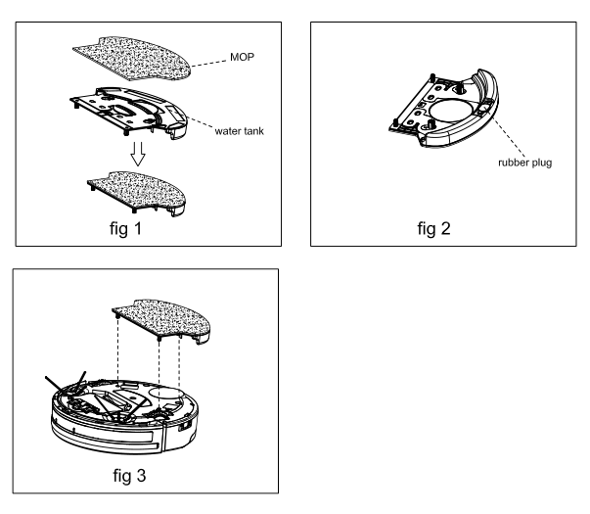

PRODUCT MAINTENANCE

Cleaning the Side Brushes
Clean the side brushes when they get dirty or replace them if they are damaged. The typical life span for the side brushes is 12 to 24 months, depending upon use.

Note: Before replacing the side brushes, check to make sure the 'L' / 'R' marks on the side brushes match with the 'L' / 'R' marks on the bottom base of the robot body.

Cleaning the Dust Bin & Filters
Empty and clean the dust bin after each vacuum session.
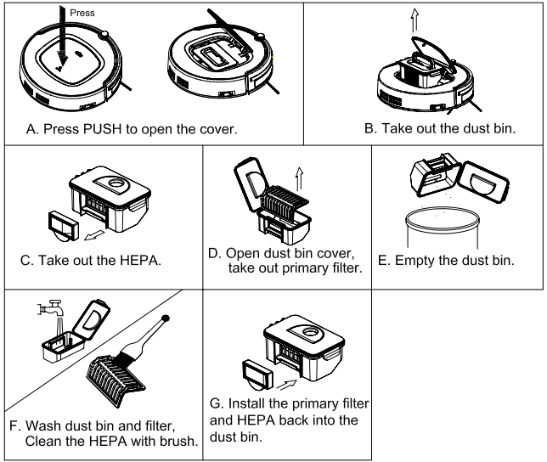
- Wash the HEPA filter after 15-30 days of use (lifespan is typically 24 - 36 months).
- Only reinstall the HEPA and primary filters once they are completely dry.
- Do not dry the filters under direct sunlight.

PRODUCT MAINTENANCE CONT.

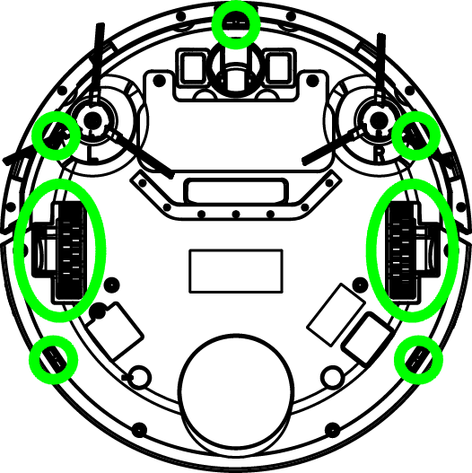
Cleaning the Sensors & Wheels
Gently wipe all the sensors and wheels (marked
in the figure to the right) with a soft cleaning cloth.

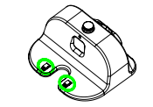
Cleaning the Charging Poles
Clean the charging poles (marked in figure to the
right) with a soft cleaning cloth.

Cleaning Suction Passage & Dust Sensor
Clean the suction passage and the dust sensor (as marked in figure below) with a soft
cleaning cloth.
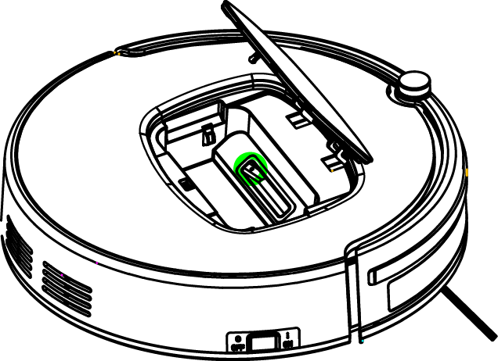

Important Note: always keep the vacuum sensors away from water.

TROUBLESHOOTING

Check the following before requesting maintenance:

TROUBLE | POSSIBLE REASONS | WHAT TO DO
The vacuum is not operating | Power is off | Turn the power switch on.
The vacuum is not operating | Battery is low/depleted | Place the vacuum on the charging station and leave it there until the battery is fully charged.
Front bumper assembly | Loose screw | Make sure the front bumper is screwed on tightly to the robot body.
Side brushes aren't working | Obstacle in the way | Make sure there are no obstacles in the way or nothing is caught in the brushes.
Wheels are stuck/not turning | Obstacle in the way | Make sure there are no obstacles in the way or nothing is caught in the wheels.

Note: If the above solutions do not work, restart the robot by turning the power switch off and then back on. If the robot vacuum is still not working, please inquire with an authorized repair person. DO NOT TRY TO REPAIR THE VACUUM ON YOUR OWN.

REMOVING THE BATTERY

Steps to take when removing the battery from the vacuum:
- Remove the screws on the battery cover with a screw driver.
- Remove the battery cover from the robot body.
- Grasp the insulating tape on both sides of the battery.
- Lift the battery out of the main vacuum body.
- Unplug the wire connector that links the battery to the robot.

Note: Only use the original battery or a replacement battery that are intended for use with this robot vacuum only. An unmatched battery may cause damage or harm.

PRODUCT SPECIFICATIONS

Classification | Item | Detail
Mechanical Specifications | Diameter | 13.38 inches
Mechanical Specifications | Height | 3.34 inches
Mechanical Specifications | Weight | 7.72 lbs.
Electrical Specifications | Power Rating | 14.6V
Electrical Specifications | Battery Specifications | Li-ion 2150mAH, 14.6V
Cleaning Specifications | Dust Bin Capacity | 0.5L
Cleaning Specifications | Charging Type | Auto Charging/ Manual Charging
Cleaning Specifications | Cleaning Mode | One key to clean & Remote control selection
Cleaning Specifications | Charging Time | About 200-300 minutes
Cleaning Specifications | Cleaning Time | Up to 90 minutes
Main Body Button Type |  | Touch button

